Question 2

 | 2018 | 2015
Min | 100 | 190
Median | 335 | 410
Max | 420 | 540
Mean | 294 | 404
SD | 87 | 121
IQ range | 155 | 210
Range | 320 | 350

- Year 2015 has a greater rate of $CO_{2}$ output on average than year 2018 since the mean and median in 2015 are greater than mean and median in 2018.
- All the three measures of spread (SD, IQ range, and range) in 2015 are greater than those in 2018. This means that year 2015 has greater variability in the rate of $CO_{2}$ output.

- Boxplot
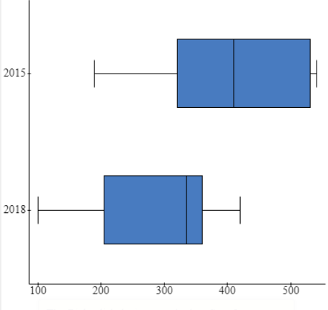
- In the year 2018, the data is skewed left. This means that there are a few data below 300.
- Justify
- True. The 3rd quartile is 360 g.
- $Q_{3}-Q_{2}=360-335=25$, $Q_{2}-Q_{1}=335-205=130$. The statement is false.
- Histogram A since the maximum value is 0.005.
Question 3
- $\left(-6,2\right), (4,16)$
- Gradient: $m=\frac{∆y}{∆x}=\frac{16-2}{4-\left(-6\right)}=\frac{14}{10}=1.4$
- Equation: $y-y_{1}=m(x-x_{1})$
$$y-16=1.4\left(x-4\right)$$
$$y=1.4x-5.6+16$$
$$y=1.4x+10.4$$
- x-intercept, y=0
$$0=1.4x+10.4$$
$$1.4x=-10.4$$
$$x=-\frac{10.4}{1.4}=-\frac{52}{7}$$
$$(-\frac{52}{7},0)$$
- When x=5, $y=1.4*5+10.4=\frac{87}{5}$
Since the value obtained when you substitute the x value with 5 in the equation of the line is not 9, this point does not lie on the line.
- Intersection
$$8x+5y=-7……..(i)$$
$$-3x+y=-\frac{1}{4}………(ii)$$
From equation $(ii)$: $y=-\frac{1}{4}+3x$
Replace this value of y in equation $(iii)$: $8x+5\left(-\frac{1}{4}+3x\right)=-7$
$$8x-\frac{5}{4}+15x=-7$$
$$23x=-7+\frac{5}{4}=-\frac{23}{4}$$
$$x=-\frac{\frac{23}{4}}{23}=-\frac{1}{4}$$
$$y=-\frac{1}{4}+3*\left(-\frac{1}{4}\right)=-1$$
$$point of intersection=(-\frac{1}{4},-1)$$
- $y=0.2x^{2}+0.15x+0.8 (-5≤x≤5)$
- y-intercept: $y=0.2{\left(0\right)}^{2}+0.15\left(0\right)+0.8=0.8$
$$(0,0.8)$$
- $x=-5$

$$y=0.2{\left(-5\right)}^{2}+0.15\left(-5\right)+0.8=5.05$$
$$point=(-5,5.05)$$
- A ladder of height 3.5 m is not long enough. The required height is 5.05 m.
- Parabola
- $0.2x^{2}+0.15x+0.8=0$
$$x_{1,2}=\frac{-b±\sqrt{b^{2}-4ac}}{2a}=\frac{-0.15±\sqrt{{0.15}^{2}-4\left(0.2\right)\left(0.8\right)}}{2*0.2}$$
$$=\frac{-0.15±\sqrt{-0.6175}}{0.4}$$
The square root of a negative number gives complex numbers. Therefore, we do not have x-intercepts
- This means that we cannot have a height of 0.

Question 4
- Simplest form

$$9x-5=-3x+1$$
$$9x+3x=1+6$$
$$12x=7$$
$$x=\frac{7}{12}$$

$$5-\frac{1}{4}\left(8+12x\right)=\frac{2}{3}x+6$$
$$5-2-3x=\frac{2}{3}x+6$$
$$\frac{2}{3}x+3x=5-2-6=-3$$
$$\frac{11}{3}x=-3$$
$$x=-\frac{9}{11}$$

$$\frac{2x}{x+3}-\frac{2}{x-2}=2$$
$$2x\left(x-2\right)-2\left(x+3\right)=2\left(x+3\right)\left(x-2\right)$$
$$2x^{2}-4x-2x-6=2x^{2}+2x-12$$
$$-6x-6=2x-12$$
$$-4x=-6$$
$$x=\frac{4}{6}=\frac{2}{3}$$

$$3x^{2}-27x+54=0$$
$$3\left(x^{2}-9x+18\right)=0$$
$$3\left(x^{2}-6x-3x+18\right)=0$$
$$3\left(x\left(x-6\right)-3\left(x-6\right)\right)=0$$
$$3\left(x-6\right)\left(x-3\right)=0$$
$$x-6=0 or x-3=0$$
$$x=6 or x=3$$

- Rearrange the formula

$$-a+\frac{6}{7}b=3b-2c(\frac{3}{2}b-3)$$
$$-7a+6b=21b-14c\left(\frac{3}{2}b-3\right)$$
$$-14a+12b=42b-14c(3b-6)$$
$$-14a+12b=42b-42bc+84c$$
$$12b-42b+42bc=84c+14a$$
$$-30b+42bc=84c+14a$$
$$b\left(-30b+42c\right)=84c+14a$$
$$b=\frac{84c+14a}{-30b+42c}=\frac{42c+7a}{-15b+21c}$$

- Mistakes
- For step 2, the student did not multiply all through by 7.
- For step 3, the student multiplied 2c by 2.
Question 5
- Find the length AC
$${\left(AC\right)}^{2}={\left(AB\right)}^{2}+{\left(BC\right)}^{2}$$
$${\left(AC\right)}^{2}={2.8}^{2}+{0.2}^{2}$$
$$AC=\sqrt{{2.8}^{2}+{0.2}^{2}}=2.8 m$$
- Circumference
$$C=πd=π\left(0.6\right)=1.9 m$$
- Revolutions
$$n=\frac{length of the ramp}{circumference of the wheel}=\frac{2.8}{1.9}=1.5 revolutions$$
- Angle of elevation
$$\tan\left(A\right)=\frac{BC}{AC}=\frac{0.2}{2.8}=$$
$$A=\tan^{-1}\left(\frac{0.2}{2.8}\right)={4.1}^{°}$$
The angle is below ${ 4.8}^{°}$, therefore, it is suitable.

- Scale model

$$\frac{A^{'}B^{'}}{AB}=\frac{10}{100}$$
$$\frac{A^{'}B^{'}}{2.8}=\frac{10}{100}$$
$$A^{'}B^{'}=\frac{10}{100}*2.8=0.28 cm$$
- The angle will be the same since the two triangles will be the same.
- Wheelchair skate park
- Length EF
$$EF=\sqrt{{\left(DE\right)}^{2}+{\left(DF\right)}^{2}-2\left(DE\right)\left(DF\right)\cos\left(D\right)}$$
$$EF=\sqrt{{3.7}^{2}+{6.2}^{2}-2*3.7*6.2cos⁡({125}^{°})}=8.9 m$$
- Angle DEF
$$\cos\left(E\right)=\frac{{\left(DE\right)}^{2}+{\left(EF\right)}^{2}-{\left(DF\right)}^{2}}{2*DE*EF}=\frac{{3.7}^{2}+{8.9}^{2}-{6.2}^{2}}{2*3.7*8.9}=0.8269$$
$$E=\cos^{-1}\left(0.8269\right)={34}^{°}$$
- Area of DEF
$$area=\frac{1}{2}*DE*DF*sin⁡(D)$$
$$=\frac{1}{2}*3.7*6.2*\sin\left({125}^{°}\right)=9.4 m^{2}$$
Question 6
- $y=15787t+22815 (0≤t≤4)$
- $t=2017-2014=3$
$$y=15787\left(3\right)+22815=70176 electric vehicles$$
- It means this model applies for year 2014,2015,2016,2017, and 2018 only.
- 50000 electric vehicles
$$15787t+22815=50000$$
$$15787t=50000-22815=27185$$
$$t=\frac{27185}{15787}=1.72≈2$$
$$year=2014+2=2016$$
- The gradient is 15787. It means that the number of vehicles increase by 15787 per year.

- Graph
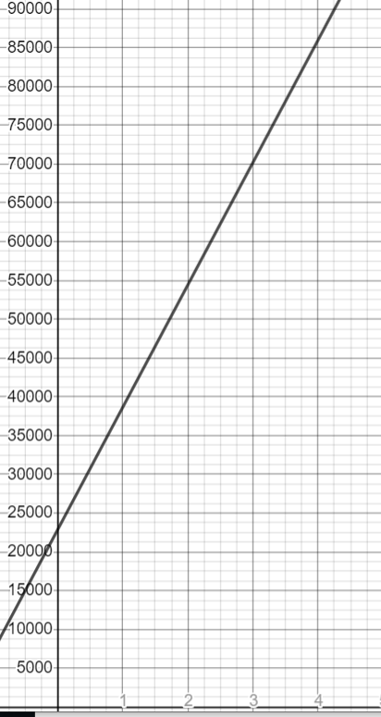
- The time variable will be negative leading to negative number of vehicles. This is not possible.
- $y=404×{\left(2.26\right)}^{t} (0≤t≤5)$
- Year 2011
$$t=2011-2009=2$$
$$y=404×{\left(2.26\right)}^{2}=2063 electric vehicles$$
- Scale factor
$$y=404×{\left(2.26\right)}^{0}=404$$
$$y=404×{\left(2.26\right)}^{1}=913.04$$
$$scale factor=\frac{913.04}{404}=2.26$$
$$\% increase=\frac{913.04-404}{404}=1.26=126\%$$
- Number of electric vehicles
$$404×{\left(2.26\right)}^{t}>11000$$
$${\left(2.26\right)}^{t}>\frac{11000}{404}$$
$${\left(2.26\right)}^{t}>27.2277$$
$${\ln\left(2.26\right)}^{t}>ln⁡(27.2277)$$
$$tln\left(2.26\right)>\ln\left(27.2277\right)$$
$$t>\frac{\ln\left(27.2277\right)}{\ln\left(2.26\right)}=4.05$$
$$Year=2009+4=2013$$

